Standard PPE Requirements For Department

Steel toe cap footwear is required for the department operation, whether these be in the form of boots or shoes, both are acceptable. Please contact you production manager immediately if you do not have the correct footwear. | 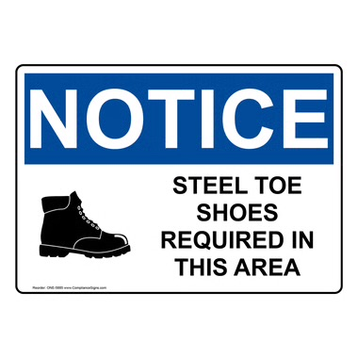
Ear protection is provided at the entrance to the department and is a requirement during production activity times. Please contact your production manager immediately if you require alternative hearing protection. | 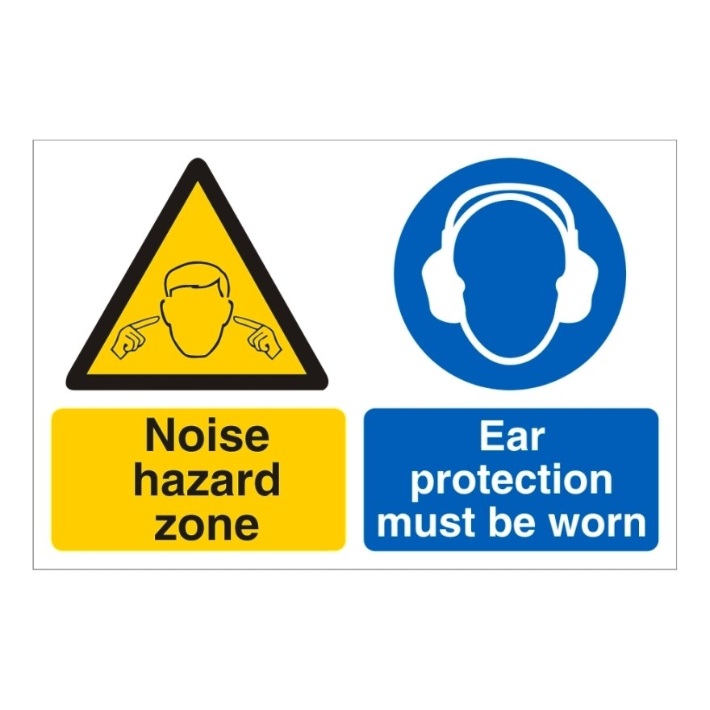

Key Purpose of The Procedure

Knife changes are a dangerous procedure and MUST ONLY BE CARRIED OUT BY FULLY TRAINED AND COMPETENT OPERATORS. It is vital to ensure that the required supplies are readily available before any knife change commences and the area is blocked off from any unauthorised employees. Before a knife change, operators MUST,

- Ensure the change is not a solo task and another trained/trainee is present at all times
- A safe working area has being established
- The area is free from obstructions
- Staff members within the department are aware that a knife change is in progress
- The machine is isolated from any movements that could occur during a knife change and interlocked guards are left open throughout the procedure

Dull Knife Procedure

When changing a foredge knife, it is important to have a new knife available before the change and an empty wooden box ready for the blunt/dull knife that is being removed. When a dull knife has been safely removed, the following must be adhered to,

- The knife is secured into the knife holder box that is specific to the foredge
- A tag is placed on the top of the knife with the dull side facing upwards, indicating that the knife needs to be sent away to be sharpened
- When the dull knife has been secured in place within the holder box, this will then need placing in the departments designated area for collection
- Collection and delivery days are Wednesdays



